Guidance on WS85 firmware upgrade
Prepare for upgrade:
- Install software “EcowittISPTool V1.0.0” on Windows PC
- Firmware “WS85_Vx.x.x_APP.hex”
- A USB to micro-USB type A data cable (not include in package)
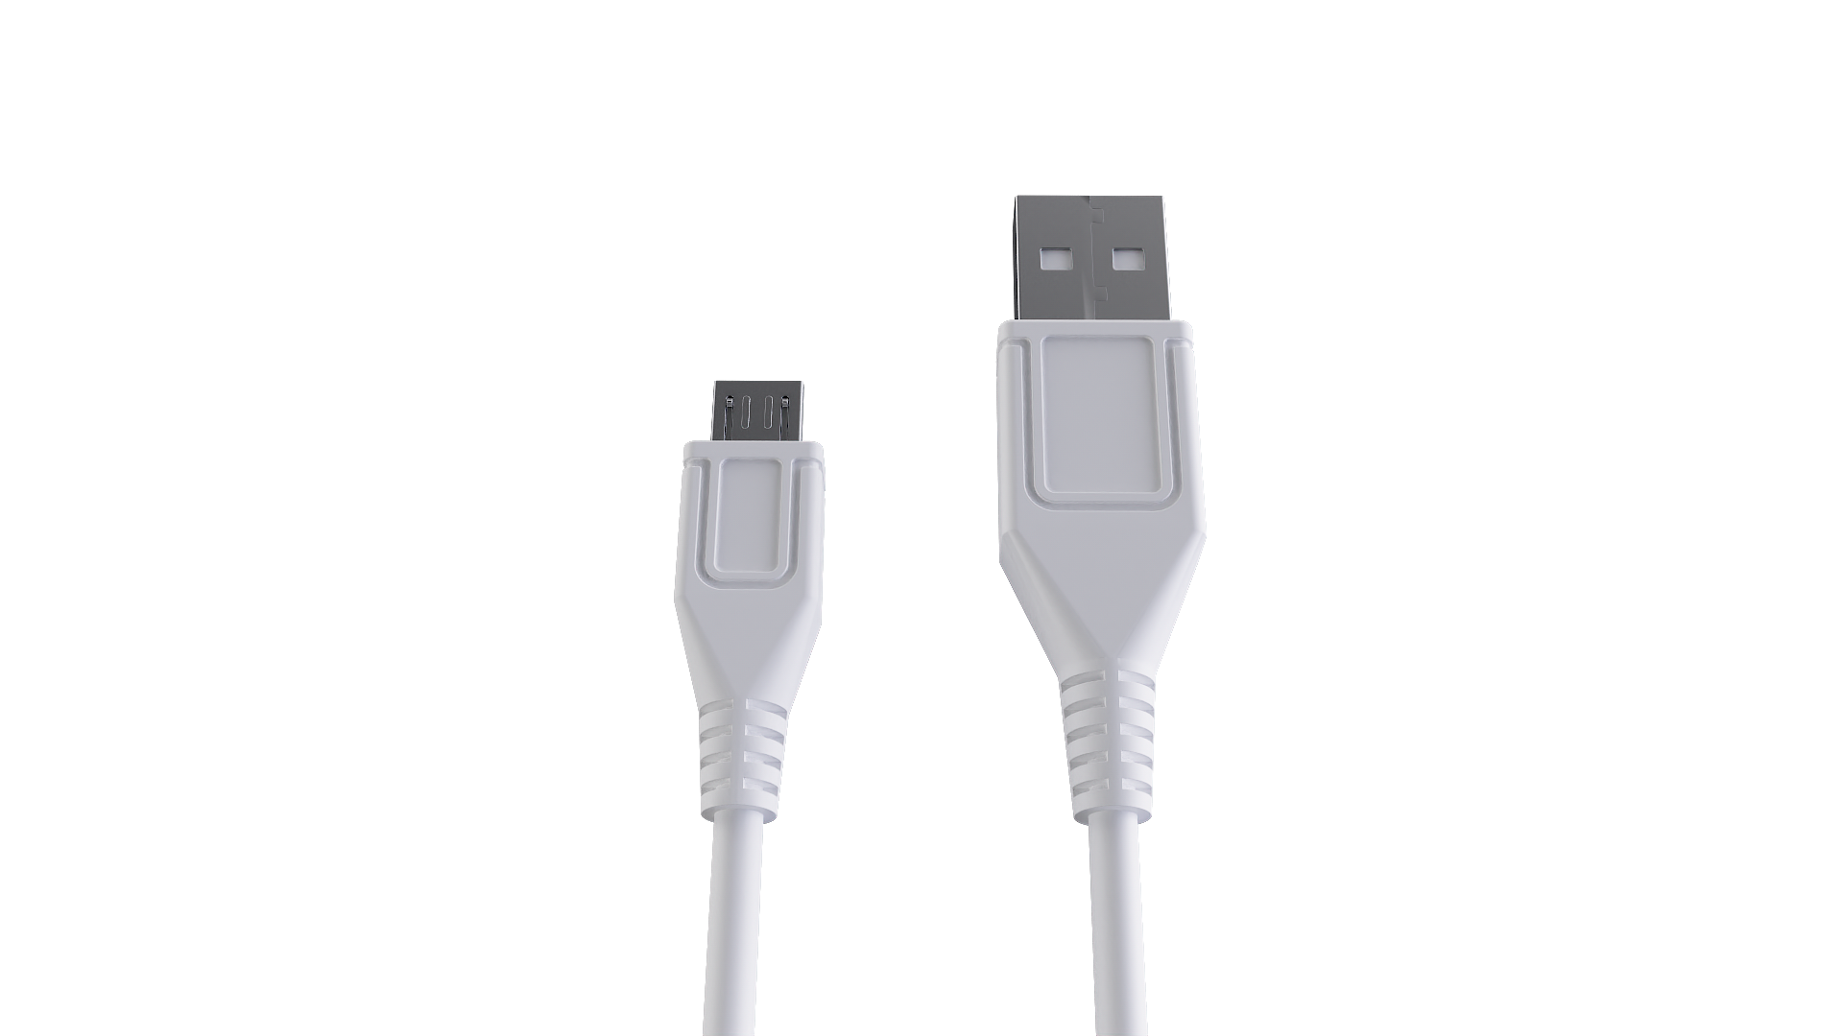
Upgrade:

- Remove the white silicone sleeve from WS85
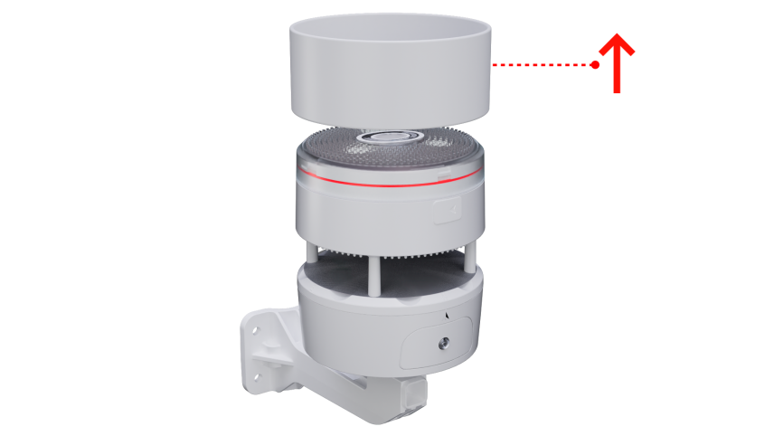
- Use a USB data cable to connect the WS85 with the PC. (Note: Not every USB cable you use for charging is a data cable.)
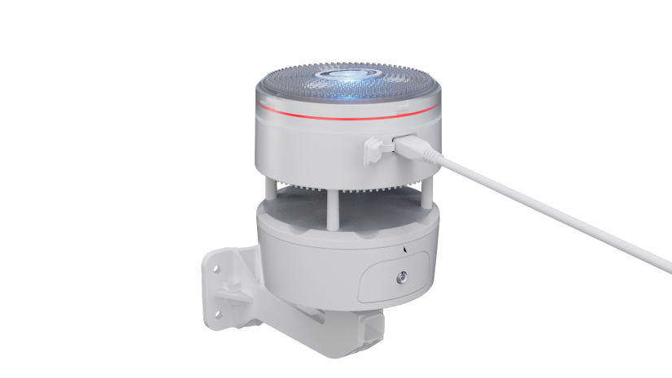
- Press the ”RESET” button on WS85 to enter boot mode
- The LED will flash quickly on the top of the WS85
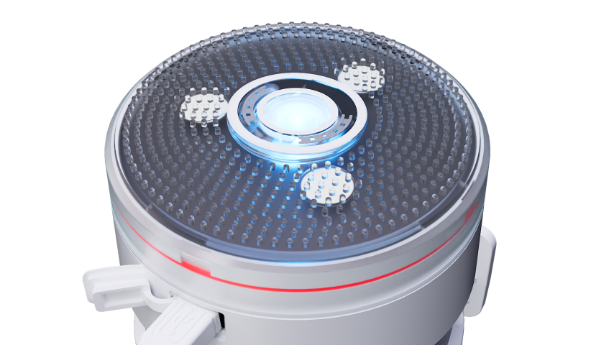
- Double-click “EcowittISPTool V1.0.0(EN).exe” after unzipping the upgrade file
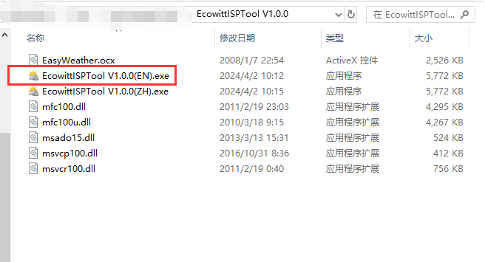
- Click “Select” to add firmware
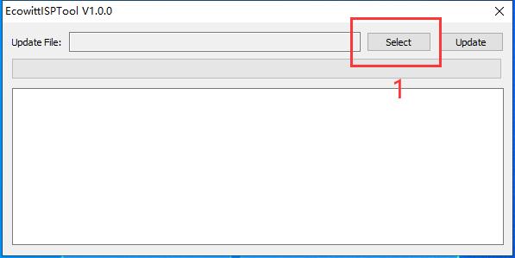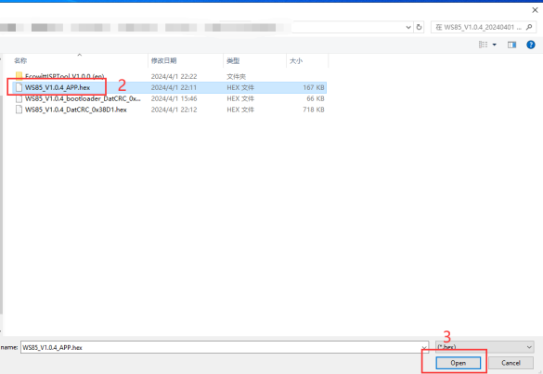
- Choose the hex file and then click “open”
- Click “Update”
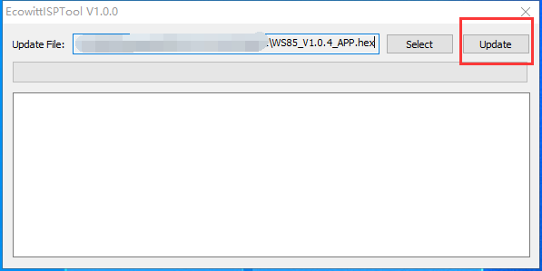
- If it shows “Upgrade successful!”, then you have done well.
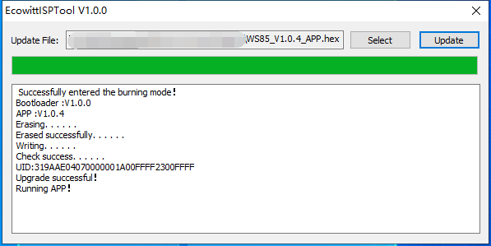
- If it shows “failed” then please checking your operation, and then contact our support.
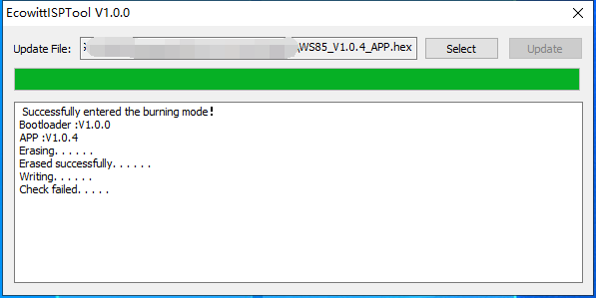

Troubleshooting:
In principle, it doesn't matter if the USB outlet you use on your computer is USB2.0 or USB3.0; USB ports, generally, can be "moody" pieces and be a nightmare. Sometimes, you have to reboot your computer first to get it to work electrically properly. Sometimes, a simple restart/reboot is not enough (warm restart), but you need a complete shutdown and a subsequent restart (cold restart) to get "the electricity" straight. Sometimes, you must change the USB port or computer before the connection gets adequately established.

